|  |  |
| --- | --- |
| Machine Type: | Bruderer 30 Tonne Press |
| Machine Centre No: | HPB |
| Serial No: | BSTA - 30 |



Machine Maintenance

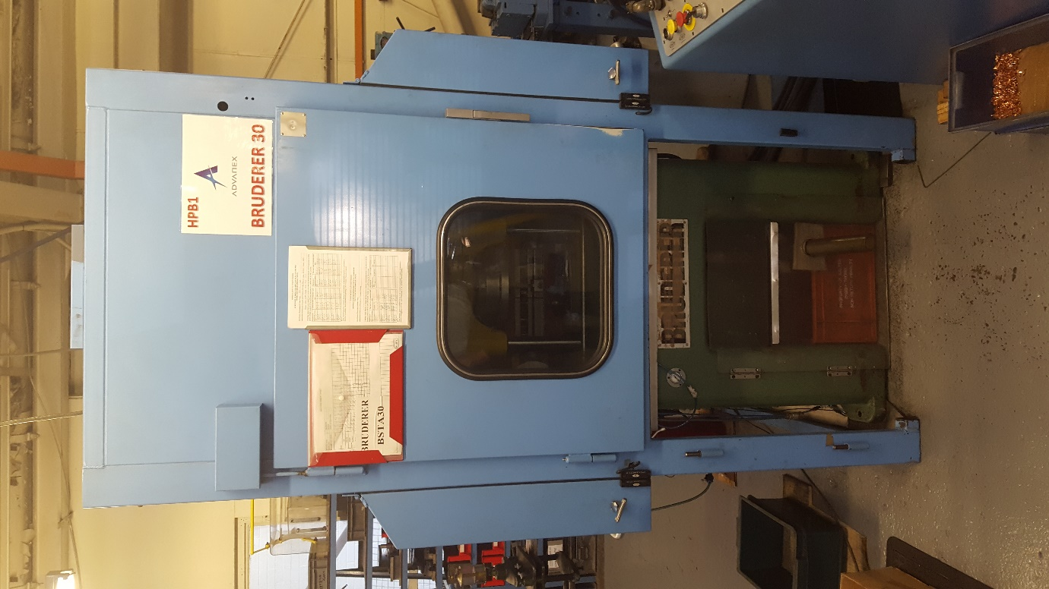

Manual & Log Book.

Document No: AEU00660 Revision: 01

CONTENTS.

SECTION 1 – MAINTENANCE SCHEDULE.

1. Start of Production Checks.
2. Weekly Checks.
3. Monthly Checks.
4. Yearly Checks.
5. Two Yearly Checks.
6. Five Yearly Checks.

SECTION 2 – SIGN OFF SHEETS.

1. Start of Production Checks.
2. Weekly Checks.
3. Monthly Checks.
4. Yearly Checks.
5. Two Yearly Checks.
6. Five Yearly Checks.

SECTION 3 – MACHINE DOWNTIME RECORED.

SECTION 4 – IMPORTANT CONTACTS.

SECTION 5 – CRITICAL SPARES LIST.

SECTION 6 – CHANGE NOTES.

1. MAINTENANCE SCHEDULE.
2. Start of Production Checks.

These checks are to be completed before production starts on every shift when the machine is used.

1. Guards and protection devices checks.
2. Weekly Checks.

These checks must be carried out once a week when the machine is used.

1. Bed-oil collector pipe – clean with rag.
2. Water separator – check, maybe empty out (Before opening containers, check that pressure is off) **\***.
3. Oil mister – check, maybe fill up with spec. oil (Before opening containers, check that pressure is off) **\***.
4. Oil pressure light – Observe, Check functioning**\***.
5. Oil pressure manometer – Observe**\***.
6. Monthly Checks.

These checks must be carried out once a month when the machine is used.

1. Bed-oil return filter – Rinse through**\***.
2. Oil pump belts – check condition and tension**\***.
3. Driving V-Belts – Check condition and tension, may be re-tension**\***.
4. Oil level – Check, may be fill up with oil**\***.
5. Columns – oil return – Check**\***.
6. Oil Pressure – Check, adjust**\***.
7. Water separator – Clean: rinse bowel & sinter filter**\***.
8. Yearly Checks.
9. Insurance Checks – Carried out annually by the Insurance company.
10. Two Yearly Checks.
11. Service – Carried out by suitable subcontractor.
12. Lubricating oil – Oil change**\***.
13. Pump filter – Clean with petrol**\***.
14. Rotor connection – Grease**\***.
15. Idler – Grease**\***.
16. Motor commutator – Check carbon brushes**\***.
17. Five Yearly Checks.
18. Motor bearings – Renew grease**\***.

**\*Refer to Manufactures manual for more details.**

1. SIGN OFF SHEETS.
2. Puwer 98 guards & protection devices checks.

**PUWER 98 (PART IV) POWER PRESSES**

**Certificate of Inspection and Test of All Guards and Protection Devices (Regulation 33)**

**Identification Particulars of Power Press:** __BSTA 30_

**Identification Particulars of Guards and protection Devices:** __Front 021, Right Side 020, Back 019, Left Side 018 & Top 017_

I hereby state that every guard and protection device detailed above is in its position on the power press to which this certificate relates and is effective for its purpose.

|  |  |  |  |
| --- | --- | --- | --- |
| Date & time of inspection & test. | | Name of appointed person | Signature of appointed person |
|  |  |  |  |
|  |  |  |  |
|  |  |  |  |
|  |  |  |  |
|  |  |  |  |
|  |  |  |  |
|  |  |  |  |
|  |  |  |  |
|  |  |  |  |
|  |  |  |  |
|  |  |  |  |
|  |  |  |  |
|  |  |  |  |
|  |  |  |  |
|  |  |  |  |
|  |  |  |  |
|  |  |  |  |
|  |  |  |  |
|  |  |  |  |
|  |  |  |  |
|  |  |  |  |
|  |  |  |  |
|  |  |  |  |
|  |  |  |  |
|  |  |  |  |
|  |  |  |  |
|  |  |  |  |
|  |  |  |  |
|  |  |  |  |
|  |  |  |  |
|  |  |  |  |
|  |  |  |  |
|  |  |  |  |

**Note: If any necessary guard or protection device is not in position, is not properly in position, is unsuitable or defective immediately inform the Head of Production.**

1. Weekly checks (When in Production).

|  |  |  |  |
| --- | --- | --- | --- |
| Date  (dd-mmm-yy) | Name  (Print) | Signature | Comments |
|  |  |  |  |
|  |  |  |  |
|  |  |  |  |
|  |  |  |  |
|  |  |  |  |
|  |  |  |  |
|  |  |  |  |
|  |  |  |  |
|  |  |  |  |
|  |  |  |  |
|  |  |  |  |
|  |  |  |  |
|  |  |  |  |
|  |  |  |  |
|  |  |  |  |
|  |  |  |  |
|  |  |  |  |
|  |  |  |  |
|  |  |  |  |
|  |  |  |  |
|  |  |  |  |
|  |  |  |  |
|  |  |  |  |
|  |  |  |  |
|  |  |  |  |
|  |  |  |  |
|  |  |  |  |
|  |  |  |  |
|  |  |  |  |
|  |  |  |  |
|  |  |  |  |
|  |  |  |  |

1. Monthly checks.

|  |  |  |  |
| --- | --- | --- | --- |
| Date  (dd-mmm-yy) | Name  (Print) | Signature | Comments |
|  |  |  |  |
|  |  |  |  |
|  |  |  |  |
|  |  |  |  |
|  |  |  |  |
|  |  |  |  |
|  |  |  |  |
|  |  |  |  |
|  |  |  |  |
|  |  |  |  |
|  |  |  |  |
|  |  |  |  |
|  |  |  |  |
|  |  |  |  |
|  |  |  |  |
|  |  |  |  |
|  |  |  |  |
|  |  |  |  |
|  |  |  |  |
|  |  |  |  |
|  |  |  |  |
|  |  |  |  |
|  |  |  |  |
|  |  |  |  |
|  |  |  |  |
|  |  |  |  |
|  |  |  |  |
|  |  |  |  |
|  |  |  |  |
|  |  |  |  |
|  |  |  |  |
|  |  |  |  |

1. Yearly checks.

|  |  |  |  |
| --- | --- | --- | --- |
| Date  (dd-mmm-yy) | Name  (Print) | Signature | Comments |
|  |  |  |  |
|  |  |  |  |
|  |  |  |  |
|  |  |  |  |
|  |  |  |  |
|  |  |  |  |
|  |  |  |  |
|  |  |  |  |
|  |  |  |  |
|  |  |  |  |
|  |  |  |  |
| 1. Two yearly checks. | | | |
| Date  (dd-mmm-yy) | Name  (Print) | Signature | Comments |
|  |  |  |  |
|  |  |  |  |
|  |  |  |  |
|  |  |  |  |
|  |  |  |  |
|  |  |  |  |
|  |  |  |  |
|  |  |  |  |
|  |  |  |  |
| 1. Five yearly checks. | | | |
| Date  (dd-mmm-yy) | Name  (Print) | Signature | Comments |
|  |  |  |  |
|  |  |  |  |
|  |  |  |  |
|  |  |  |  |
|  |  |  |  |
|  |  |  |  |

1. MACHINE DOWNTIME RECORED.

|  |  |  |  |
| --- | --- | --- | --- |
| Date | Description | Batch  No. | Repair  Date |
|  |  |  |  |
| Date | Description | Batch  No. | Repair  Date |
|  |  |  |  |
| Date | Description | Batch  No. | Repair  Date |
|  |  |  |  |
| Date | Description | Batch  No. | Repair  Date |
|  |  |  |  |
| Date | Description | Batch  No. | Repair  Date |
|  |  |  |  |
| Date | Description | Batch  No. | Repair  Date |
|  |  |  |  |
| Date | Description | Batch  No. | Repair  Date |
|  |  |  |  |
| Date | Description | Batch  No. | Repair  Date |
|  |  |  |  |

1. IMPORTANT CONTACTS.

|  |  |  |
| --- | --- | --- |
| Name | Company / Address | Telephone No. |
| Andy Harrison | Allianz Insurance  Midlands Region Engineer Surveyors  Allianz Engineering  Haslemere Road  Liphook  Hampshire  GU30 7UN | 01428 722407 / 01483 265837 |
| Neil Walls | Presscare Uk Ltd. | 0845 2267617 |
| John Carsley | Trent oils  Phoenix House Kemmel Road, Bulwell Nottingham Nottinghamshire NG6 9FH | 0845 2701122 |
| Kelvin Dennis | KD Electrical | 07702 401173 |

1. CRITICAL SPARES LIST.

Hydraulic Oil 32

1. CHANGE NOTES.

|  |  |  |  |
| --- | --- | --- | --- |
| Revision Level | Description | Date | Name |
| 01 | First Issue | 27TH Oct 2016 | Christopher Rowntree |
|  |  |  |  |