|  |  |
| --- | --- |
| Machine Type: | Flat Bed Press |
| M/C & Serial No: | HPV |



Machine Maintenance

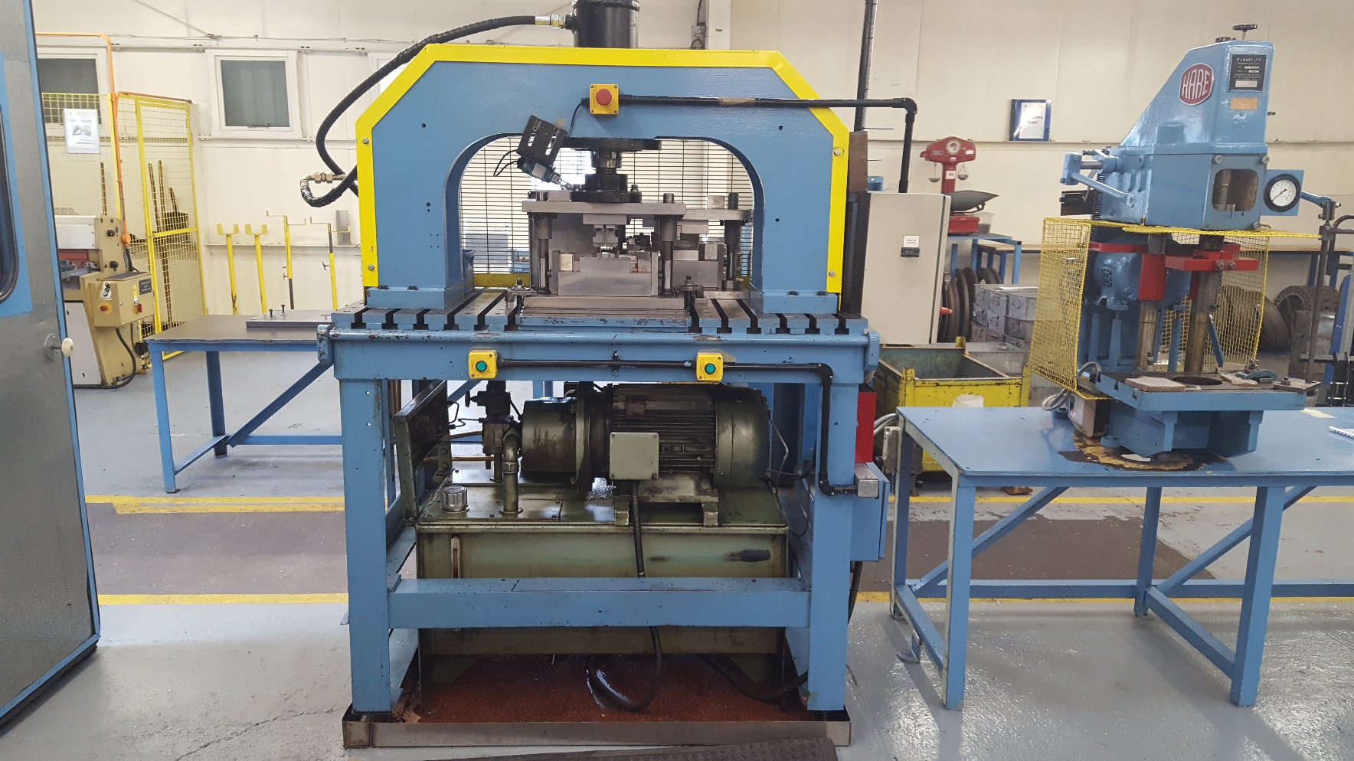

Manual & Log Book.

Document No: AEU00677 Revision: 01

CONTENTS.

SECTION 1 – MAINTENANCE SCHEDULE.

1. Daily Checks.
2. Monthly Checks.
3. Yearly Checks.

SECTION 2 – SIGN OFF SHEETS.

1. Daily Checks.
2. Monthly Checks.
3. Yearly Checks.

SECTION 3 – MACHINE DOWNTIME RECORED.

SECTION 4 – IMPORTANT CONTACTS.

SECTION 5 – CRITICAL SPARES LIST.

SECTION 6 – CHANGE NOTES.

1. MAINTENANCE SCHEDULE.
2. Daily Checks.

These checks are to be completed before production starts on every shift when the machine is used.

1. Check for oil leaks.
2. Check all press frame bolts for breakages (underload).
3. Monthly Checks.

These checks must be carried out once a month when the machine is used.

1. Check oil level.
2. Check condition of ram connecting hose.
3. Yearly Checks.
4. Visual check of frame for possible fractures.
5. SIGN OFF SHEETS.
6. Daily checks (When in Production).

|  |  |  |  |
| --- | --- | --- | --- |
| Date  (dd-mmm-yy) | Name  (Print) | Signature | Comments |
|  |  |  |  |
|  |  |  |  |
|  |  |  |  |
|  |  |  |  |
|  |  |  |  |
|  |  |  |  |
|  |  |  |  |
|  |  |  |  |
|  |  |  |  |
|  |  |  |  |
|  |  |  |  |
|  |  |  |  |
|  |  |  |  |
|  |  |  |  |
|  |  |  |  |
|  |  |  |  |
|  |  |  |  |
|  |  |  |  |
|  |  |  |  |
|  |  |  |  |
|  |  |  |  |
|  |  |  |  |
|  |  |  |  |
|  |  |  |  |
|  |  |  |  |
|  |  |  |  |
|  |  |  |  |
|  |  |  |  |
|  |  |  |  |
|  |  |  |  |
|  |  |  |  |

1. Monthly checks (When in production).

|  |  |  |  |
| --- | --- | --- | --- |
| Date  (dd-mmm-yy) | Name  (Print) | Signature | Comments |
|  |  |  |  |
|  |  |  |  |
|  |  |  |  |
|  |  |  |  |
|  |  |  |  |
|  |  |  |  |
|  |  |  |  |
|  |  |  |  |
|  |  |  |  |
|  |  |  |  |
|  |  |  |  |
|  |  |  |  |
|  |  |  |  |
|  |  |  |  |
|  |  |  |  |
|  |  |  |  |
|  |  |  |  |
|  |  |  |  |
|  |  |  |  |
|  |  |  |  |
|  |  |  |  |
|  |  |  |  |
|  |  |  |  |
|  |  |  |  |
|  |  |  |  |
|  |  |  |  |
|  |  |  |  |
|  |  |  |  |
|  |  |  |  |
|  |  |  |  |
|  |  |  |  |
|  |  |  |  |

1. Yearly checks.

|  |  |  |  |
| --- | --- | --- | --- |
| Date  (dd-mmm-yy) | Name  (Print) | Signature | Comments |
|  |  |  |  |
|  |  |  |  |
|  |  |  |  |
|  |  |  |  |
|  |  |  |  |
|  |  |  |  |
|  |  |  |  |
|  |  |  |  |
|  |  |  |  |
|  |  |  |  |
|  |  |  |  |
|  |  |  |  |
|  |  |  |  |
|  |  |  |  |
|  |  |  |  |
|  |  |  |  |
|  |  |  |  |
|  |  |  |  |
|  |  |  |  |
|  |  |  |  |
|  |  |  |  |
|  |  |  |  |
|  |  |  |  |
|  |  |  |  |
|  |  |  |  |
|  |  |  |  |
|  |  |  |  |
|  |  |  |  |
|  |  |  |  |
|  |  |  |  |
|  |  |  |  |
|  |  |  |  |

1. MACHINE DOWNTIME RECORED.

|  |  |  |  |
| --- | --- | --- | --- |
| Date | Description | Batch  No. | Repair  Date |
|  |  |  |  |
| Date | Description | Batch  No. | Repair  Date |
|  |  |  |  |
| Date | Description | Batch  No. | Repair  Date |
|  |  |  |  |
| Date | Description | Batch  No. | Repair  Date |
|  |  |  |  |
| Date | Description | Batch  No. | Repair  Date |
|  |  |  |  |
| Date | Description | Batch  No. | Repair  Date |
|  |  |  |  |
| Date | Description | Batch  No. | Repair  Date |
|  |  |  |  |
| Date | Description | Batch  No. | Repair  Date |
|  |  |  |  |

1. IMPORTANT CONTACTS.

|  |  |  |
| --- | --- | --- |
| Name | Company / Address | Telephone No. |
| Andy Richardson | Sear Engineering Services  5 Enterprise Way  Jubilee Business Park  Derby  DE21 4BB | 01332 200000 |
| John Carsley | Trent oils  Phoenix House Kemmel Road, Bulwell Nottingham Nottinghamshire NG6 9FH | 0845 2701122 |
| Kelvin Dennis | KD Electrical | 07702 401173 |

1. CRITICAL SPARES LIST.

Hydraulic Oil 32

1. CHANGE NOTES.

|  |  |  |  |
| --- | --- | --- | --- |
| Revision Level | Description | Date | Name |
| 01 | First Issue | 10TH Apr 2017 | Christopher Rowntree |
|  |  |  |  |