|  |  |
| --- | --- |
| Machine Type: | Hare 5BS Hydraulic Presses |
| Machine Centre No: | HPH |



Machine Maintenance

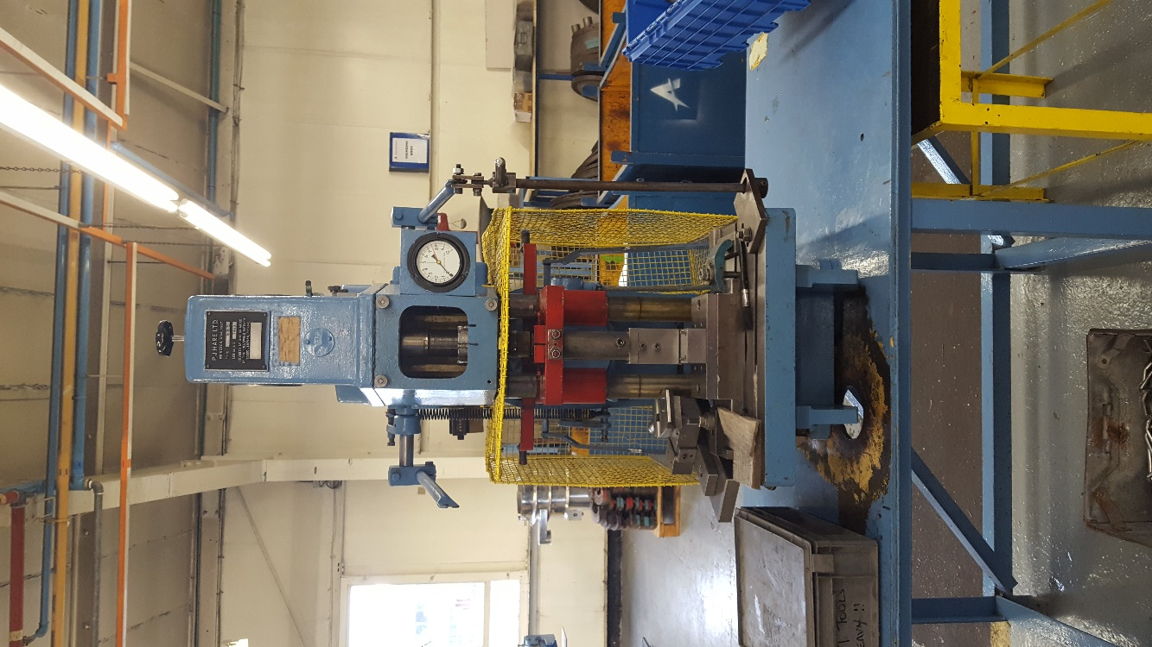

Manual & Log Book.

Document No: AEU00675 Revision: 01

CONTENTS.

SECTION 1 – MAINTENANCE SCHEDULE.

1. Start of Production Checks.
2. Weekly Checks.
3. Monthly Checks.
4. Yearly Checks.

SECTION 2 – IMPORTANT CONTACTS.

SECTION 3 – CRITICAL SPARES LIST.

SECTION 4 – CHANGE NOTES.

SECTION 5 – HPHa.

1. Sign Off Sheets.
2. Machine Downtime Record.

SECTION 6 – HPHb.

1. Sign Off Sheets.
2. Machine Downtime Record.

SECTION 1 - MAINTENANCE SCHEDULE.

1. Start of Production Checks.

These checks are to be completed before production starts on every shift when the machine is used.

1. Guards and Trapping areas if applicable.
2. Check for excessive leaks from the hydraulics system (A small leak is expected).
3. Weekly Checks.

These checks must be carried out once a week when the machine is used.

1. Check oil reservoir level.
2. Monthly Checks.

These checks must be carried out once a month when the machine is used.

1. Check ram for play.
2. Yearly Checks.
3. Visual inspection of hydraulic pipe work.

SECTION 2 - IMPORTANT CONTACTS.

|  |  |  |
| --- | --- | --- |
| Name | Company / Address | Telephone No. |
|  | Trent Oils  Phoenix House  Kemmel Road  Bulwell  Nottingham  NG6 9FH | 0845 270 1122 |

SECTION 3 - CRITICAL SPARES.

Hydraulic Oil 32

SECTION 4 - CHANGE NOTES.

|  |  |  |  |
| --- | --- | --- | --- |
| Revision Level | Description | Date | Name |
| 01 | First Issue | 13th Mar 2017 | Christopher Rowntree |
|  |  |  |  |

SECTION 5 – HPHa.

Serial Number: 8650

1. Sign Off Sheets

Start of production checks.

|  |  |  |  |
| --- | --- | --- | --- |
| Date  (dd-mmm-yy) | Name  (Print) | Signature | Comments |
|  |  |  |  |
|  |  |  |  |
|  |  |  |  |
|  |  |  |  |
|  |  |  |  |
|  |  |  |  |
|  |  |  |  |
|  |  |  |  |
|  |  |  |  |
|  |  |  |  |
|  |  |  |  |
|  |  |  |  |
|  |  |  |  |
|  |  |  |  |
|  |  |  |  |
|  |  |  |  |
|  |  |  |  |
|  |  |  |  |
|  |  |  |  |
|  |  |  |  |
|  |  |  |  |
|  |  |  |  |
|  |  |  |  |
|  |  |  |  |
|  |  |  |  |
|  |  |  |  |
|  |  |  |  |
|  |  |  |  |
|  |  |  |  |
|  |  |  |  |
|  |  |  |  |
|  |  |  |  |

* + 1. Weekly checks (When in Production).

|  |  |  |  |
| --- | --- | --- | --- |
| Date  (dd-mmm-yy) | Name  (Print) | Signature | Comments |
|  |  |  |  |
|  |  |  |  |
|  |  |  |  |
|  |  |  |  |
|  |  |  |  |
|  |  |  |  |
|  |  |  |  |
|  |  |  |  |
|  |  |  |  |
|  |  |  |  |
|  |  |  |  |
|  |  |  |  |
|  |  |  |  |
|  |  |  |  |
|  |  |  |  |
|  |  |  |  |
|  |  |  |  |
|  |  |  |  |
|  |  |  |  |
|  |  |  |  |
|  |  |  |  |
|  |  |  |  |
|  |  |  |  |
|  |  |  |  |
|  |  |  |  |
|  |  |  |  |
|  |  |  |  |
|  |  |  |  |
|  |  |  |  |
|  |  |  |  |
|  |  |  |  |
|  |  |  |  |

* + 1. Monthly checks.

|  |  |  |  |
| --- | --- | --- | --- |
| Date  (dd-mmm-yy) | Name  (Print) | Signature | Comments |
|  |  |  |  |
|  |  |  |  |
|  |  |  |  |
|  |  |  |  |
|  |  |  |  |
|  |  |  |  |
|  |  |  |  |
|  |  |  |  |
|  |  |  |  |
|  |  |  |  |
|  |  |  |  |
|  |  |  |  |
|  |  |  |  |
|  |  |  |  |
|  |  |  |  |
|  |  |  |  |
|  |  |  |  |
|  |  |  |  |
|  |  |  |  |
|  |  |  |  |
|  |  |  |  |
|  |  |  |  |
|  |  |  |  |
|  |  |  |  |
|  |  |  |  |
|  |  |  |  |
|  |  |  |  |
|  |  |  |  |
|  |  |  |  |
|  |  |  |  |
|  |  |  |  |
|  |  |  |  |

* + 1. Yearly checks.

|  |  |  |  |
| --- | --- | --- | --- |
| Date  (dd-mmm-yy) | Name  (Print) | Signature | Comments |
|  |  |  |  |
|  |  |  |  |
|  |  |  |  |
|  |  |  |  |
|  |  |  |  |
|  |  |  |  |
|  |  |  |  |
|  |  |  |  |
|  |  |  |  |
|  |  |  |  |
|  |  |  |  |
|  |  |  |  |
|  |  |  |  |
|  |  |  |  |
|  |  |  |  |
|  |  |  |  |

1. MACHINE DOWNTIME RECORED.

|  |  |  |  |
| --- | --- | --- | --- |
| Date | Description | Batch  No. | Repair  Date |
|  |  |  |  |
| Date | Description | Batch  No. | Repair  Date |
|  |  |  |  |

SECTION 6 – HPHb.

Serial Number: 7493

1. Sign Off Sheets
   * 1. Start of production checks.

|  |  |  |  |
| --- | --- | --- | --- |
| Date  (dd-mmm-yy) | Name  (Print) | Signature | Comments |
|  |  |  |  |
|  |  |  |  |
|  |  |  |  |
|  |  |  |  |
|  |  |  |  |
|  |  |  |  |
|  |  |  |  |
|  |  |  |  |
|  |  |  |  |
|  |  |  |  |
|  |  |  |  |
|  |  |  |  |
|  |  |  |  |
|  |  |  |  |
|  |  |  |  |
|  |  |  |  |
|  |  |  |  |
|  |  |  |  |
|  |  |  |  |
|  |  |  |  |
|  |  |  |  |
|  |  |  |  |
|  |  |  |  |
|  |  |  |  |
|  |  |  |  |
|  |  |  |  |
|  |  |  |  |
|  |  |  |  |
|  |  |  |  |
|  |  |  |  |
|  |  |  |  |
|  |  |  |  |

* + 1. Weekly checks (When in Production).

|  |  |  |  |
| --- | --- | --- | --- |
| Date  (dd-mmm-yy) | Name  (Print) | Signature | Comments |
|  |  |  |  |
|  |  |  |  |
|  |  |  |  |
|  |  |  |  |
|  |  |  |  |
|  |  |  |  |
|  |  |  |  |
|  |  |  |  |
|  |  |  |  |
|  |  |  |  |
|  |  |  |  |
|  |  |  |  |
|  |  |  |  |
|  |  |  |  |
|  |  |  |  |
|  |  |  |  |
|  |  |  |  |
|  |  |  |  |
|  |  |  |  |
|  |  |  |  |
|  |  |  |  |
|  |  |  |  |
|  |  |  |  |
|  |  |  |  |
|  |  |  |  |
|  |  |  |  |
|  |  |  |  |
|  |  |  |  |
|  |  |  |  |
|  |  |  |  |
|  |  |  |  |
|  |  |  |  |

* + 1. Monthly checks.

|  |  |  |  |
| --- | --- | --- | --- |
| Date  (dd-mmm-yy) | Name  (Print) | Signature | Comments |
|  |  |  |  |
|  |  |  |  |
|  |  |  |  |
|  |  |  |  |
|  |  |  |  |
|  |  |  |  |
|  |  |  |  |
|  |  |  |  |
|  |  |  |  |
|  |  |  |  |
|  |  |  |  |
|  |  |  |  |
|  |  |  |  |
|  |  |  |  |
|  |  |  |  |
|  |  |  |  |
|  |  |  |  |
|  |  |  |  |
|  |  |  |  |
|  |  |  |  |
|  |  |  |  |
|  |  |  |  |
|  |  |  |  |
|  |  |  |  |
|  |  |  |  |
|  |  |  |  |
|  |  |  |  |
|  |  |  |  |
|  |  |  |  |
|  |  |  |  |
|  |  |  |  |
|  |  |  |  |

* + 1. Yearly checks.

|  |  |  |  |
| --- | --- | --- | --- |
| Date  (dd-mmm-yy) | Name  (Print) | Signature | Comments |
|  |  |  |  |
|  |  |  |  |
|  |  |  |  |
|  |  |  |  |
|  |  |  |  |
|  |  |  |  |
|  |  |  |  |
|  |  |  |  |
|  |  |  |  |
|  |  |  |  |
|  |  |  |  |
|  |  |  |  |
|  |  |  |  |
|  |  |  |  |
|  |  |  |  |
|  |  |  |  |

1. MACHINE DOWNTIME RECORED.

|  |  |  |  |
| --- | --- | --- | --- |
| Date | Description | Batch  No. | Repair  Date |
|  |  |  |  |
| Date | Description | Batch  No. | Repair  Date |
|  |  |  |  |