|  |  |
| --- | --- |
| Machine Type: | HME G30 Power Press |
| Machine Centre No: | HP30 |
| Serial No: | 14197 |



Machine Maintenance

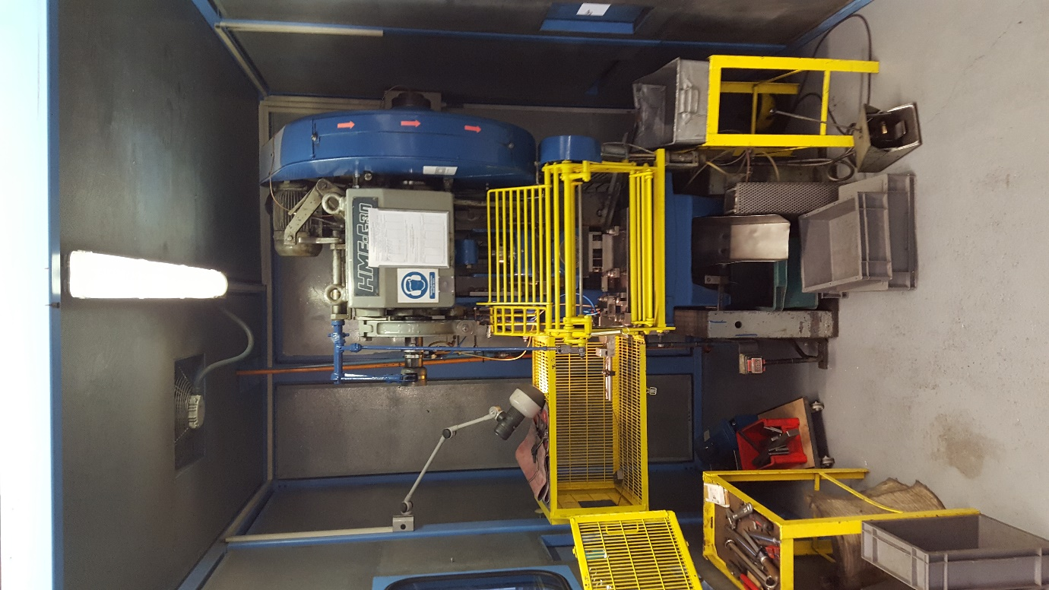

Manual & Log Book.

Document No: AEU00672 Revision: 01

CONTENTS.

SECTION 1 – MAINTENANCE SCHEDULE.

1. Start of Production Checks.
2. Weekly Checks.
3. Monthly Checks.
4. Yearly Checks.
5. Two Yearly Checks.

SECTION 2 – SIGN OFF SHEETS.

1. Start of Production Checks.
2. Weekly Checks.
3. Monthly Checks.
4. Yearly Checks.
5. Two Yearly Checks.

SECTION 3 – MACHINE DOWNTIME RECORED.

SECTION 4 – IMPORTANT CONTACTS.

SECTION 5 – CRITICAL SPARES LIST.

SECTION 6 – CHANGE NOTES.

1. MAINTENANCE SCHEDULE.
2. Start of Production Checks.

These checks are to be completed before production starts on every shift when the machine is used.

1. Guards and protection devices checks.
2. Check level in oil reservoir.
3. Visual check of brake pads.
4. Pump the manual hydraulic oil system twice.
5. Weekly Checks.

These checks must be carried out once a week when the machine is used.

1. Check water separator and drain if required.
2. Check oil mister and fill if required.
3. Monthly Checks.

These checks must be carried out once a month when the machine is used.

1. Visual check condition of flywheel belt.
2. Check ram for play.
3. Yearly Checks.
4. Insurance Checks – Carried out annually by the Insurance company.
5. Two Yearly Checks.
6. Service – Carried out by suitable subcontractor.
7. SIGN OFF SHEETS.
8. Start of Production Checks .
9. Puwer 98 guards & protection devices checks.

**PUWER 98 (PART IV) POWER PRESSES**

**Certificate of Inspection and Test of All Guards and Protection Devices (Regulation 33)**

**Identification Particulars of Power Press:** __HME-G30 14197_

**Identification Particulars of Guards and protection Devices:** __Front 22, Left 23/25, Top 24, Right 26, Back 27/28 _

I hereby state that every guard and protection device detailed above is in its position on the power press to which this certificate relates and is effective for its purpose.

|  |  |  |  |
| --- | --- | --- | --- |
| Date & time of inspection & test. | | Name of appointed person | Signature of appointed person |
|  |  |  |  |
|  |  |  |  |
|  |  |  |  |
|  |  |  |  |
|  |  |  |  |
|  |  |  |  |
|  |  |  |  |
|  |  |  |  |
|  |  |  |  |
|  |  |  |  |
|  |  |  |  |
|  |  |  |  |
|  |  |  |  |
|  |  |  |  |
|  |  |  |  |
|  |  |  |  |
|  |  |  |  |
|  |  |  |  |
|  |  |  |  |
|  |  |  |  |
|  |  |  |  |
|  |  |  |  |
|  |  |  |  |
|  |  |  |  |
|  |  |  |  |
|  |  |  |  |
|  |  |  |  |
|  |  |  |  |
|  |  |  |  |
|  |  |  |  |
|  |  |  |  |
|  |  |  |  |

**Note: If any necessary guard or protection device is not in position, is not properly in position, is unsuitable or defective immediately inform the Head of Production.**

1. Other Start of production checks.

|  |  |  |  |
| --- | --- | --- | --- |
| Date  (dd-mmm-yy) | Name  (Print) | Signature | Comments |
|  |  |  |  |
|  |  |  |  |
|  |  |  |  |
|  |  |  |  |
|  |  |  |  |
|  |  |  |  |
|  |  |  |  |
|  |  |  |  |
|  |  |  |  |
|  |  |  |  |
|  |  |  |  |
|  |  |  |  |
|  |  |  |  |
|  |  |  |  |
|  |  |  |  |
|  |  |  |  |
|  |  |  |  |
|  |  |  |  |
|  |  |  |  |
|  |  |  |  |
|  |  |  |  |
|  |  |  |  |
|  |  |  |  |
|  |  |  |  |
|  |  |  |  |
|  |  |  |  |
|  |  |  |  |
|  |  |  |  |
|  |  |  |  |
|  |  |  |  |
|  |  |  |  |
|  |  |  |  |

1. Weekly checks (When in Production).

|  |  |  |  |
| --- | --- | --- | --- |
| Date  (dd-mmm-yy) | Name  (Print) | Signature | Comments |
|  |  |  |  |
|  |  |  |  |
|  |  |  |  |
|  |  |  |  |
|  |  |  |  |
|  |  |  |  |
|  |  |  |  |
|  |  |  |  |
|  |  |  |  |
|  |  |  |  |
|  |  |  |  |
|  |  |  |  |
|  |  |  |  |
|  |  |  |  |
|  |  |  |  |
|  |  |  |  |
|  |  |  |  |
|  |  |  |  |
|  |  |  |  |
|  |  |  |  |
|  |  |  |  |
|  |  |  |  |
|  |  |  |  |
|  |  |  |  |
|  |  |  |  |
|  |  |  |  |
|  |  |  |  |
|  |  |  |  |
|  |  |  |  |
|  |  |  |  |
|  |  |  |  |
|  |  |  |  |

1. Monthly checks.

|  |  |  |  |
| --- | --- | --- | --- |
| Date  (dd-mmm-yy) | Name  (Print) | Signature | Comments |
|  |  |  |  |
|  |  |  |  |
|  |  |  |  |
|  |  |  |  |
|  |  |  |  |
|  |  |  |  |
|  |  |  |  |
|  |  |  |  |
|  |  |  |  |
|  |  |  |  |
|  |  |  |  |
|  |  |  |  |
|  |  |  |  |
|  |  |  |  |
|  |  |  |  |
|  |  |  |  |
|  |  |  |  |
|  |  |  |  |
|  |  |  |  |
|  |  |  |  |
|  |  |  |  |
|  |  |  |  |
|  |  |  |  |
|  |  |  |  |
|  |  |  |  |
|  |  |  |  |
|  |  |  |  |
|  |  |  |  |
|  |  |  |  |
|  |  |  |  |
|  |  |  |  |
|  |  |  |  |

1. Yearly checks.

|  |  |  |  |
| --- | --- | --- | --- |
| Date  (dd-mmm-yy) | Name  (Print) | Signature | Comments |
|  |  |  |  |
|  |  |  |  |
|  |  |  |  |
|  |  |  |  |
|  |  |  |  |
|  |  |  |  |
|  |  |  |  |
|  |  |  |  |
|  |  |  |  |
|  |  |  |  |
|  |  |  |  |
|  |  |  |  |
|  |  |  |  |
|  |  |  |  |
|  |  |  |  |
|  |  |  |  |
| 1. Two Yearly checks. | | | |
| Date  (dd-mmm-yy) | Name  (Print) | Signature | Comments |
|  |  |  |  |
|  |  |  |  |
|  |  |  |  |
|  |  |  |  |
|  |  |  |  |
|  |  |  |  |
|  |  |  |  |
|  |  |  |  |
|  |  |  |  |
|  |  |  |  |

1. MACHINE DOWNTIME RECORED.

|  |  |  |  |
| --- | --- | --- | --- |
| Date | Description | Batch  No. | Repair  Date |
|  |  |  |  |
| Date | Description | Batch  No. | Repair  Date |
|  |  |  |  |
| Date | Description | Batch  No. | Repair  Date |
|  |  |  |  |
| Date | Description | Batch  No. | Repair  Date |
|  |  |  |  |
| Date | Description | Batch  No. | Repair  Date |
|  |  |  |  |
| Date | Description | Batch  No. | Repair  Date |
|  |  |  |  |
| Date | Description | Batch  No. | Repair  Date |
|  |  |  |  |
| Date | Description | Batch  No. | Repair  Date |
|  |  |  |  |

1. IMPORTANT CONTACTS.

|  |  |  |
| --- | --- | --- |
| Name | Company / Address | Telephone No. |
| Andy Harrison | Allianz Insurance  Midlands Region Engineer Surveyors  Allianz Engineering  Haslemere Road  Liphook  Hampshire  GU30 7UN | 01428 722407 / 01483 265837 |
| Neil Walls | Presscare Uk Ltd. | 0845 2267617 |
| John Carsley | Trent oils  Phoenix House Kemmel Road, Bulwell Nottingham Nottinghamshire NG6 9FH | 0845 2701122 |
| Kelvin Dennis | KD Electrical | 07702 401173 |

1. CRITICAL SPARES LIST.

Hydraulic Oil 32

1. CHANGE NOTES.

|  |  |  |  |
| --- | --- | --- | --- |
| Revision Level | Description | Date | Name |
| 01 | First Issue | 19th Jan 2017 | Christopher Rowntree |
|  |  |  |  |