|  |  |
| --- | --- |
| CMA Location: |  |
| P&P Line Identification: |  |



Pickle & Passivation Line

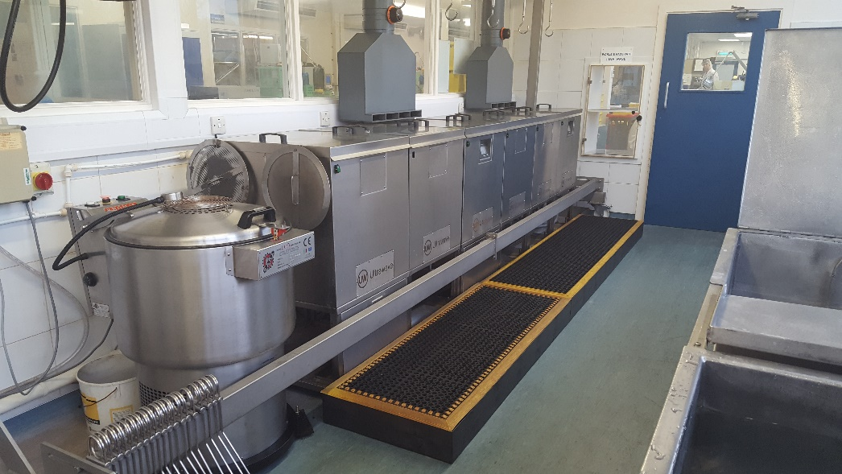

Maintenance Log Book.

Document No: AEU00635 Revision: 01

**Contents.**

1. Associated Documents.
2. Critical Spares.
3. Filter Change Record.
4. Weekly Rinse Tank Clean Down Record.
5. Weekly Titration Test Record.
6. Monthly Clean Down & Acid Change Record.
7. Line Downtime & Maintenance Record.
8. Important Contacts.
9. Change Notes.
11. **Associated Documents.** (Can be found at www.aeums.co.uk)
12. AEU00604 - Pickle and Passivation Titration Tests & Rectification.
13. AEU00631 - Pickle and Passivation Tank Clean Down.
14. AEU00633 - Pickle and Passivation Filter Change.
15. AEU00634 - Pickle and Passivation Daily Check Sheet.
16. AEU00648 – Pickle and Passivation Daily Work Log.
17. AEU00651 - Pickle and Passivation Titration Test Record.
18. AEU00652 - Clean Manufacturing Area & Pickle and Passivation Maintenance Schedule.
19. Pickle and Passivation Titration Test Record (Can be found at G:\DATA\PRODUCTION ENGINEERING\Plant and equipment\Production Machinery Records\Pickle And Passivation)
20. **Critical Spares.**
21. Filter - CG328 - 50µm 10” PP Filter Cartridge.
22. Pump Housing Seals - 11-2001-08 EPDM Gasket.
23. **Filter Change Record.**

|  |  |  |  |
| --- | --- | --- | --- |
| Date  (dd-mmm-yy) | Start Production / End Production | Print Name | Sign |
|  |  |  |  |
|  |  |  |  |
|  |  |  |  |
|  |  |  |  |
|  |  |  |  |
|  |  |  |  |
|  |  |  |  |
|  |  |  |  |
|  |  |  |  |
|  |  |  |  |
|  |  |  |  |
|  |  |  |  |
|  |  |  |  |
|  |  |  |  |
|  |  |  |  |
|  |  |  |  |
|  |  |  |  |
|  |  |  |  |
|  |  |  |  |
|  |  |  |  |
|  |  |  |  |
|  |  |  |  |
|  |  |  |  |
|  |  |  |  |
|  |  |  |  |
|  |  |  |  |
|  |  |  |  |
|  |  |  |  |
|  |  |  |  |
|  |  |  |  |
|  |  |  |  |
|  |  |  |  |
|  |  |  |  |
|  |  |  |  |
|  |  |  |  |
|  |  |  |  |
|  |  |  |  |
|  |  |  |  |
| Date  (dd-mmm-yy) | Start Production / End Production | Print Name | Sign |
|  |  |  |  |
|  |  |  |  |
|  |  |  |  |
|  |  |  |  |
|  |  |  |  |
|  |  |  |  |
|  |  |  |  |
|  |  |  |  |
|  |  |  |  |
|  |  |  |  |
|  |  |  |  |
|  |  |  |  |
|  |  |  |  |
|  |  |  |  |
|  |  |  |  |
|  |  |  |  |
|  |  |  |  |
|  |  |  |  |
|  |  |  |  |
|  |  |  |  |
|  |  |  |  |
|  |  |  |  |
|  |  |  |  |
|  |  |  |  |
|  |  |  |  |
|  |  |  |  |
|  |  |  |  |
|  |  |  |  |
|  |  |  |  |
|  |  |  |  |
|  |  |  |  |
|  |  |  |  |
|  |  |  |  |
|  |  |  |  |
|  |  |  |  |
|  |  |  |  |
|  |  |  |  |
|  |  |  |  |
|  |  |  |  |
|  |  |  |  |

1. **Weekly Rinse Tank Clean Down Record.**

|  |  |  |  |
| --- | --- | --- | --- |
| Date  (dd-mmm-yy) | Start Production / End Production | Print Name | Sign |
|  |  |  |  |
|  |  |  |  |
|  |  |  |  |
|  |  |  |  |
|  |  |  |  |
|  |  |  |  |
|  |  |  |  |
|  |  |  |  |
|  |  |  |  |
|  |  |  |  |
|  |  |  |  |
|  |  |  |  |
|  |  |  |  |
|  |  |  |  |
|  |  |  |  |
|  |  |  |  |
|  |  |  |  |
|  |  |  |  |
|  |  |  |  |
|  |  |  |  |
|  |  |  |  |
|  |  |  |  |
|  |  |  |  |
|  |  |  |  |
|  |  |  |  |
|  |  |  |  |
|  |  |  |  |
|  |  |  |  |
|  |  |  |  |
|  |  |  |  |
|  |  |  |  |
|  |  |  |  |
|  |  |  |  |
|  |  |  |  |
|  |  |  |  |
|  |  |  |  |
|  |  |  |  |
|  |  |  |  |
| Date  (dd-mmm-yy) | Start Production / End Production | Print Name | Sign |
|  |  |  |  |
|  |  |  |  |
|  |  |  |  |
|  |  |  |  |
|  |  |  |  |
|  |  |  |  |
|  |  |  |  |
|  |  |  |  |
|  |  |  |  |
|  |  |  |  |
|  |  |  |  |
|  |  |  |  |
|  |  |  |  |
|  |  |  |  |
|  |  |  |  |
|  |  |  |  |
|  |  |  |  |
|  |  |  |  |
|  |  |  |  |
|  |  |  |  |
|  |  |  |  |
|  |  |  |  |
|  |  |  |  |
|  |  |  |  |
|  |  |  |  |
|  |  |  |  |
|  |  |  |  |
|  |  |  |  |
|  |  |  |  |
|  |  |  |  |
|  |  |  |  |
|  |  |  |  |
|  |  |  |  |
|  |  |  |  |
|  |  |  |  |
|  |  |  |  |
|  |  |  |  |
|  |  |  |  |
|  |  |  |  |
|  |  |  |  |

1. **Weekly Titration Test Record.**

|  |  |  |
| --- | --- | --- |
| Date  (dd-mmm-yy) | Print Name | Sign |
|  |  |  |
|  |  |  |
|  |  |  |
|  |  |  |
|  |  |  |
|  |  |  |
|  |  |  |
|  |  |  |
|  |  |  |
|  |  |  |
|  |  |  |
|  |  |  |
|  |  |  |
|  |  |  |
|  |  |  |
|  |  |  |
|  |  |  |
|  |  |  |
|  |  |  |
|  |  |  |
|  |  |  |
|  |  |  |
|  |  |  |
|  |  |  |
|  |  |  |
|  |  |  |
|  |  |  |
|  |  |  |
|  |  |  |
|  |  |  |
|  |  |  |
|  |  |  |
|  |  |  |
|  |  |  |
|  |  |  |
|  |  |  |
|  |  |  |
|  |  |  |
| Date  (dd-mmm-yy) | Print Name | Sign |
|  |  |  |
|  |  |  |
|  |  |  |
|  |  |  |
|  |  |  |
|  |  |  |
|  |  |  |
|  |  |  |
|  |  |  |
|  |  |  |
|  |  |  |
|  |  |  |
|  |  |  |
|  |  |  |
|  |  |  |
|  |  |  |
|  |  |  |
|  |  |  |
|  |  |  |
|  |  |  |
|  |  |  |
|  |  |  |
|  |  |  |
|  |  |  |
|  |  |  |
|  |  |  |
|  |  |  |
|  |  |  |
|  |  |  |
|  |  |  |
|  |  |  |
|  |  |  |
|  |  |  |
|  |  |  |
|  |  |  |
|  |  |  |
|  |  |  |
|  |  |  |
|  |  |  |

1. **Monthly Clean Down & Acid Change.**

|  |  |  |  |
| --- | --- | --- | --- |
| Date  (dd-mmm-yy) | Comments (N/A if Nothing) | Print Name | Sign |
|  |  |  |  |
|  |  |  |  |
|  |  |  |  |
|  |  |  |  |
|  |  |  |  |
|  |  |  |  |
|  |  |  |  |
|  |  |  |  |
|  |  |  |  |
|  |  |  |  |
|  |  |  |  |
|  |  |  |  |
|  |  |  |  |
|  |  |  |  |
|  |  |  |  |
|  |  |  |  |
|  |  |  |  |
|  |  |  |  |
|  |  |  |  |
|  |  |  |  |
|  |  |  |  |
|  |  |  |  |
|  |  |  |  |
|  |  |  |  |

1. **Line Downtime & Maintenance Record.**

|  |  |  |  |
| --- | --- | --- | --- |
| Date  (dd-mmm-yy) | Description | Batch  No. | Repair  Date |
|  |  |  |  |
| Date  (dd-mmm-yy) | Description | Batch  No. | Repair  Date |
|  |  |  |  |
| Date  (dd-mmm-yy) | Description | Batch  No. | Repair  Date |
|  |  |  |  |
| Date  (dd-mmm-yy) | Description | Batch  No. | Repair  Date |
|  |  |  |  |
| Date  (dd-mmm-yy) | Description | Batch  No. | Repair  Date |
|  |  |  |  |
| Date  (dd-mmm-yy) | Description | Batch  No. | Repair  Date |
|  |  |  |  |
| Date  (dd-mmm-yy) | Description | Batch  No. | Repair  Date |
|  |  |  |  |
| Date  (dd-mmm-yy) | Description | Batch  No. | Repair  Date |
|  |  |  |  |
| Date  (dd-mmm-yy) | Description | Batch  No. | Repair  Date |
|  |  |  |  |
| Date  (dd-mmm-yy) | Description | Batch  No. | Repair  Date |
|  |  |  |  |

1. **Important Contacts.**

|  |  |  |
| --- | --- | --- |
| Name | Company / Address | Telephone No. |
| Sue Green  Tim Pearson | Electrotech  Unit 2 Swan Park  Kettlebrook Rd  Tamworth  B77 1AG  Electronics Engineers | 01827 63989  tim.pearson@electrotechweb.com |
| Tom Cobb  James Faulkner | Pneu-Thern  Telford Drive,  Brunel Drive Industrial Estate, Newark, Nottinghamshire  NG24 2DX  Passivation Heating Elements | 01636 679415  tom@pneutherm.com |
| Neville Wisbey | Siebec UK Ltd.  Unit 3 St. Albans Business Park,  St. Albans Rd,  Stafford  ST16 3DR  Pumps | 01785 227700  nevillewisbey@siebec.co.uk |
| Jane Bradley | Stowlin Croftshaw  Radnor Road,  South Wigston,  Leicester,  LE18 4XY  Acids | 07860 868345  Janebradley@stowlin.com |
| David Musto  Stephen Noyce  Phil Collins | Ultrawave  Eastgate Business Park,  Wentloog Avenue  Cardiff  CF3 2EY  P&P Tanks / Equipment | 0845 330 4236  savid.musto@ultrawave.co.uk  stephen.noyce@ultrawave.co.uk |
| Ian Thomas | Ellig Filtration  Unit 4  Gilchrist Industrial Estate  Blaenavon  Pontypool  Torfaen  NP4 9RL  Filters | 07472 157806  01495 215909  iant@ellig-filtration.com |
|  |  |  |

1. **Change Notes.**

|  |  |  |  |
| --- | --- | --- | --- |
| Revision Level | Description | Date | Sign |
| 01 | First Release | 16th Dec 2016 | C. Rowntree |
|  |  |  |  |