|  |  |
| --- | --- |
| Machine Type: | SEYI SN1-80 Power Press |
| Machine Centre No: | HP80 |
| Serial No: | EW80-2886 |



Machine Maintenance

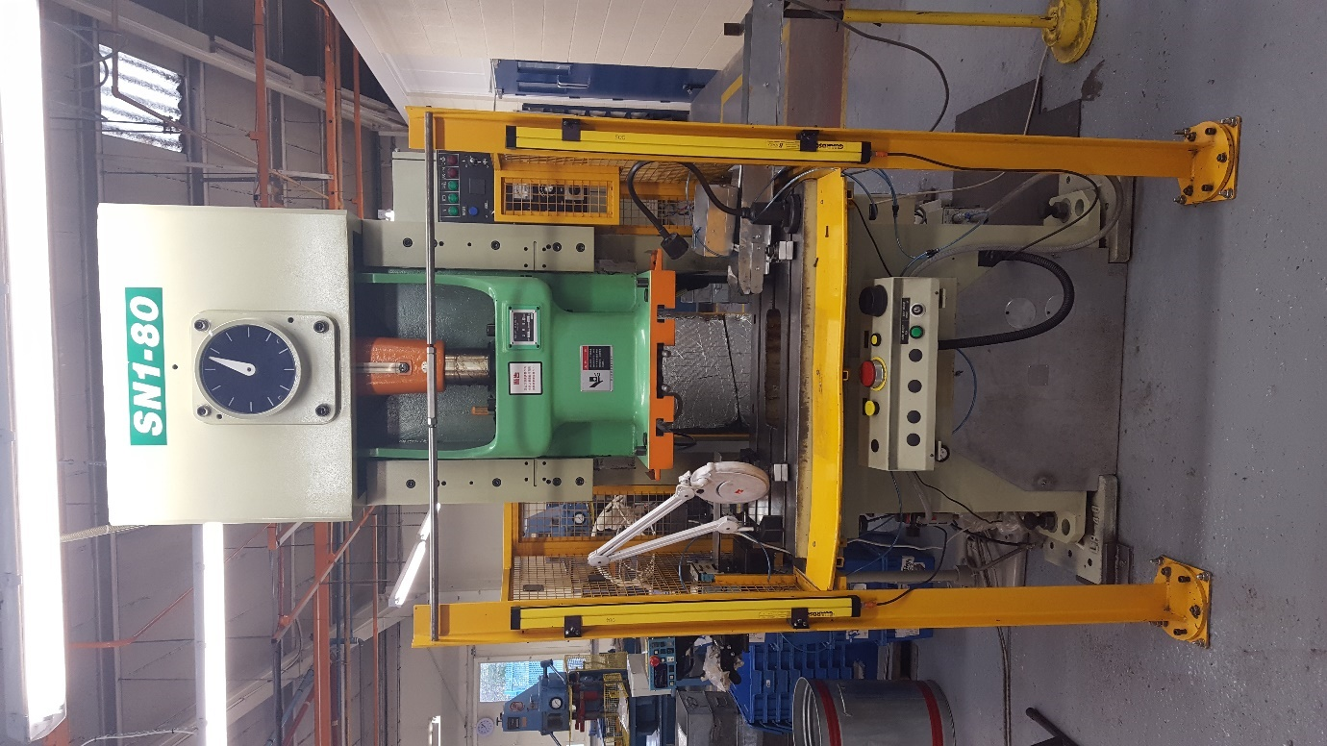

Manual & Log Book.

Document No: AEU00662 Revision: 01

CONTENTS.

SECTION 1 – MAINTENANCE SCHEDULE.

1. Start of Production Checks.
2. Weekly Checks.
3. Monthly Checks.
4. Six Monthly Checks.
5. Yearly Checks.

SECTION 2 – SIGN OFF SHEETS.

1. Start of Production Checks.
2. Weekly Checks.
3. Monthly Checks.
4. Six Monthly Checks.
5. Yearly Checks.

SECTION 3 – MACHINE DOWNTIME RECORED.

SECTION 4 – IMPORTANT CONTACTS.

SECTION 5 – CRITICAL SPARES LIST.

SECTION 6 – CHANGE NOTES.

1. MAINTENANCE SCHEDULE.
2. Start of Production Checks.

These checks are to be completed before production starts on every shift when the machine is used.

1. Guards and protection devices checks.
2. Weekly Checks.

These checks must be carried out once a week when the machine is used.

1. Oil Level Check – Check if the level of all oil level gages is between the upper and the lower limit.
2. Pneumatic Equipment & Piping – check for any leaks.
3. Check pressure is 5kg/cm2.
4. Drain moisture from filter.
5. Power Source Lamp – After power source turn on, check the **power source** lamp is lit.
6. V-Belts slipping or Vibrating – After main motor **start** button is depressed, **main motor** green lamp lights, flywheel rotates in the direction indicated by an arrow, V-belts have no slipping noise and vibration.
7. Monthly Checks.

These checks must be carried out once a month when the machine is used.

1. Check cables – Cable leading to the slide, cables for portable push button panel, etc. for damage. Receptacles for tightness.
2. Drain Air Tank – Open the valve on bottom of air tank to drain moisture.
3. Clean Filter – Clean filter and lubricator with air blowing and washing.
4. Six Monthly Checks.
5. Rotary Cam Limit – Check rotary cam limit switch. Make sure it is not damaged.
6. V-Belts - Check for correct tension and cracking.
7. Buttons & Switches – Clean of dust and soil. Ensure smooth operation.
8. Relay Contacts – Visual check of surface condition.
9. Yearly Checks.
10. Insurance Checks – Carried out annually by the Insurance company.
11. Service – Carried out by suitable subcontractor.
12. SIGN OFF SHEETS.
13. Puwer 98 guards & protection devices checks.

**PUWER 98 (PART IV) POWER PRESSES**

**Certificate of Inspection and Test of All Guards and Protection Devices (Regulation 33)**

**Identification Particulars of Power Press:** __EW 80 2886_

**Identification Particulars of Guards and protection Devices:** __Side 001 & 002, AP1/2, ICS 006, Scrap 013, Back 003, Light Guards 004 005 _

I hereby state that every guard and protection device detailed above is in its position on the power press to which this certificate relates and is effective for its purpose.

|  |  |  |  |
| --- | --- | --- | --- |
| Date & time of inspection & test. | | Name of appointed person | Signature of appointed person |
|  |  |  |  |
|  |  |  |  |
|  |  |  |  |
|  |  |  |  |
|  |  |  |  |
|  |  |  |  |
|  |  |  |  |
|  |  |  |  |
|  |  |  |  |
|  |  |  |  |
|  |  |  |  |
|  |  |  |  |
|  |  |  |  |
|  |  |  |  |
|  |  |  |  |
|  |  |  |  |
|  |  |  |  |
|  |  |  |  |
|  |  |  |  |
|  |  |  |  |
|  |  |  |  |
|  |  |  |  |
|  |  |  |  |
|  |  |  |  |
|  |  |  |  |
|  |  |  |  |
|  |  |  |  |
|  |  |  |  |
|  |  |  |  |
|  |  |  |  |
|  |  |  |  |
|  |  |  |  |
|  |  |  |  |

**Note: If any necessary guard or protection device is not in position, is not properly in position, is unsuitable or defective immediately inform the Head of Production.**

1. Weekly checks (When in Production).

|  |  |  |  |
| --- | --- | --- | --- |
| Date  (dd-mmm-yy) | Name  (Print) | Signature | Comments |
|  |  |  |  |
|  |  |  |  |
|  |  |  |  |
|  |  |  |  |
|  |  |  |  |
|  |  |  |  |
|  |  |  |  |
|  |  |  |  |
|  |  |  |  |
|  |  |  |  |
|  |  |  |  |
|  |  |  |  |
|  |  |  |  |
|  |  |  |  |
|  |  |  |  |
|  |  |  |  |
|  |  |  |  |
|  |  |  |  |
|  |  |  |  |
|  |  |  |  |
|  |  |  |  |
|  |  |  |  |
|  |  |  |  |
|  |  |  |  |
|  |  |  |  |
|  |  |  |  |
|  |  |  |  |
|  |  |  |  |
|  |  |  |  |
|  |  |  |  |
|  |  |  |  |
|  |  |  |  |

1. Monthly checks.

|  |  |  |  |
| --- | --- | --- | --- |
| Date  (dd-mmm-yy) | Name  (Print) | Signature | Comments |
|  |  |  |  |
|  |  |  |  |
|  |  |  |  |
|  |  |  |  |
|  |  |  |  |
|  |  |  |  |
|  |  |  |  |
|  |  |  |  |
|  |  |  |  |
|  |  |  |  |
|  |  |  |  |
|  |  |  |  |
|  |  |  |  |
|  |  |  |  |
|  |  |  |  |
|  |  |  |  |
|  |  |  |  |
|  |  |  |  |
|  |  |  |  |
|  |  |  |  |
|  |  |  |  |
|  |  |  |  |
|  |  |  |  |
|  |  |  |  |
|  |  |  |  |
|  |  |  |  |
|  |  |  |  |
|  |  |  |  |
|  |  |  |  |
|  |  |  |  |
|  |  |  |  |
|  |  |  |  |

1. Six monthly checks.

|  |  |  |  |
| --- | --- | --- | --- |
| Date  (dd-mmm-yy) | Name  (Print) | Signature | Comments |
|  |  |  |  |
|  |  |  |  |
|  |  |  |  |
|  |  |  |  |
|  |  |  |  |
|  |  |  |  |
|  |  |  |  |
|  |  |  |  |
|  |  |  |  |
|  |  |  |  |
|  |  |  |  |
|  |  |  |  |
|  |  |  |  |
|  |  |  |  |
|  |  |  |  |
|  |  |  |  |
| 1. Yearly checks. | | | |
| Date  (dd-mmm-yy) | Name  (Print) | Signature | Comments |
|  |  |  |  |
|  |  |  |  |
|  |  |  |  |
|  |  |  |  |
|  |  |  |  |
|  |  |  |  |
|  |  |  |  |
|  |  |  |  |
|  |  |  |  |
|  |  |  |  |

1. MACHINE DOWNTIME RECORED.

|  |  |  |  |
| --- | --- | --- | --- |
| Date | Description | Batch  No. | Repair  Date |
|  |  |  |  |
| Date | Description | Batch  No. | Repair  Date |
|  |  |  |  |
| Date | Description | Batch  No. | Repair  Date |
|  |  |  |  |
| Date | Description | Batch  No. | Repair  Date |
|  |  |  |  |
| Date | Description | Batch  No. | Repair  Date |
|  |  |  |  |
| Date | Description | Batch  No. | Repair  Date |
|  |  |  |  |
| Date | Description | Batch  No. | Repair  Date |
|  |  |  |  |
| Date | Description | Batch  No. | Repair  Date |
|  |  |  |  |

1. IMPORTANT CONTACTS.

|  |  |  |
| --- | --- | --- |
| Name | Company / Address | Telephone No. |
| Andy Harrison | Allianz Insurance  Midlands Region Engineer Surveyors  Allianz Engineering  Haslemere Road  Liphook  Hampshire  GU30 7UN | 01428 722407 / 01483 265837 |
| Neil Walls | Presscare Uk Ltd. | 0845 2267617 |
| John Carsley | Trent oils  Phoenix House Kemmel Road, Bulwell Nottingham Nottinghamshire NG6 9FH | 0845 2701122 |
| Kelvin Dennis | KD Electrical | 07702 401173 |

1. CRITICAL SPARES LIST.

Hydraulic Oil 32

1. CHANGE NOTES.

|  |  |  |  |
| --- | --- | --- | --- |
| Revision Level | Description | Date | Name |
| 01 | First Issue | 10th Nov 2016 | Christopher Rowntree |
|  |  |  |  |